Thurston County Fire District Three | 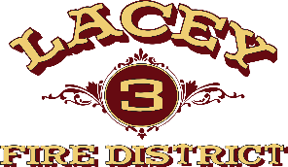

Agenda for the

Board of Volunteer Firefighters Meeting

September 19, 2024

5:25 P.M.
- call to order
- NEW BUSINESS
- John Anderson Pension Eligibility Adjustment (adding 1970-1975)
The Board for Volunteer Firefighters rules require the Local Board sign the Pension Eligibility and participation forms.
Staff recommends that the Pension Participation Certification Form be signed.
- ADJOURN

